ECSEL JU Symposium 2019 a Great Success!

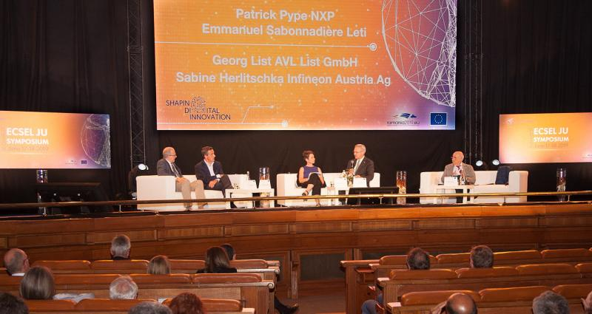

Following the very successful editions held in Malta and Brussels, ECSEL Joint Undertaking’s Symposium for 2019 would be held under the auspices of the Romanian Presidency of the Council of the European Union. ECSEL JU was particularly proud and thankful that Presidency officials offered the use of the historic and spectacular Palace of Parliament in Bucharest to hold the event!

As ever, it is clear from the programme that the annual Symposium event is designed to go beyond a discussion about technical aspects of the ECSEL JU programme. The panel sessions not only demonstrate the political and societal importance of the ECSEL JU programme, they also seek to maintain and advance the added value of the ECSEL JU as an effective European collaborative RD&I instrument, for the benefit of European citizens and businesses. The combination on the one hand of tackling less obvious issues, such as technology sovereignty, presenting alternative views of the future (like it or not, agree with it or not – such presentations are ever thought-provoking), and on the other, giving a platform to ECSEL JU projects and Lighthouse Initiatives to show off their progress (in a completely revamped exhibition format, too) made for a particularly strong message: instruments like ECSEL JU must be an essential element in any future programme that has the ambition and scale to elicit positive change and growth through investing in scientific and technological progress.  
Striking was the presentation by Romano Hoofman from imec (a leading European research and technology organisation), who stressed that prioritizing research & innovation (R&I) is needed to overcome this challenge:  the widening digital skills gap. The European Commission even predicts 756.000 unfilled jobs in the European ICT sector by 2020, slowing down the Digital Transformation of Europe.

The crucial role of speed and a guided sense of urgency in R&I activities was also a common point that came out from the panel discussions. While it is essential to agree on a common strategic research agenda (as has already largely been achieved), it is of paramount importance to speed up its implementation. Funding entities across Europe need to keep collaborating to set priorities and make sure new ideas are well balanced and executed, recognising the context in a globally competitive and rapidly evolving domain.

An answer was given through the presentation by Lars Leger, Chief Technology Officer at NXP, who recognised that “ECSEL JU keeps EU Electronic Eco-systems at the Forefront of Technology”, based on achievements such as a solid and long term SRA, creating a unified vision and good alignment via the lighthouse initiatives, and having a mid/long-term vision, providing the momentum in Europe to engage in large-scale projects that thrive on diverse partnerships with a mixture of large / medium / small enterprises and excellent RTOs. The elements are there – we now need to capitalise on them and move forward briskly.

Bert De Colvenaer, Executive Director of ECSEL JU expressed great satisfaction with the event’s outcomes, which have confirmed the ECSEL JU’s role as the “leading European strategic initiative for focused, coordinated and competitive R&I activities in Key Digital Technologies, and the ECSEL JU Symposium as an important showcase for the important work ongoing”.  
In addition to the formal presentations, and as witnessed by several important parallel meetings organise by and for high-level representatives of Industry and the institutions, the event’s ample networking opportunities provided space and excellent opportunity to involve the ECS community as well as the EU policy makers and other potential stakeholders in developing a common view towards the Horizon Europe programme, at an important juncture in the decision making processes.